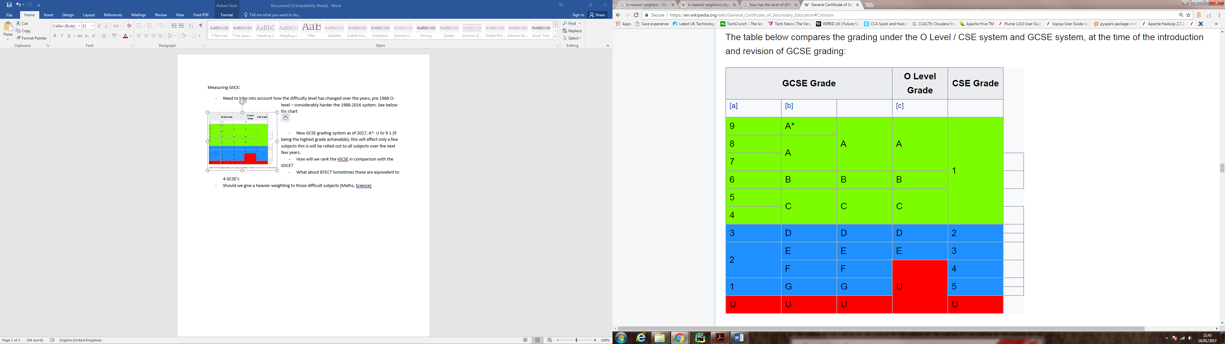**Measuring GSCE:**

* Need to take into account how the difficulty level has changed over the years, pre 1988 O-level – considerably harder the 1988-2016 system.
* New GCSE grading system as of 2017, A*- U to 9-1 (9 being the highest grade achievable), this will affect only a few subjects, the new grading systems will be rolled out to all subjects over the next few years.
* How will we rank the iGCSE in comparison with the GSCE?
* What about BTEC, GNVQs? Sometimes these are equivalent to 4 GCSE’s
* Should we give a heavier weighting to those difficult subjects (Maths, Science)

<http://www.score-education.org/media/3194/relativedifficulty.pdf>

Chart measuring relative difficulty level of subjects. By Durham University

<https://educationdatalab.org.uk/2016/02/which-are-the-most-difficult-subjects-at-gcse/>

Tables gives change in log-odds/logits (alternative to expressing probability) of higher grades compared to maths

* This is a government published document, relating to the difficulty of GCSE’s and A-Levels:

<https://www.gov.uk/government/uploads/system/uploads/attachment_data/file/486936/3-inter-subject-comparability-of-exam-standards-in-gcse-and-a-level.pdf>

**Measuring A-Level:**

* Should we give a heavier weighting to those difficult subjects (Maths, Science)

<http://www.score-education.org/media/3194/relativedifficulty.pdf>

Nice chart measuring relative difficulty level of subjects. By Durham University

* Note that we need to take into account the A* grade which was introduced in 2010
* New style of A-Levels introduced in 2015 (art and design, biology, business studies, chemistry, computing, economics, English language, English language and literature, English literature, history, physics, psychology, sociology). You sit the AS and A-Level at the end of the two years. Other subjects:

<http://university.which.co.uk/advice/a-level-choices/a-level-changes-what-it-means-for-you>

**Measuring School/College:**

* Use OFSTED reports/ranking. We can link MyEcho to this gov. website to extract dets of the schools:

<https://www.compare-school-performance.service.gov.uk/>

* Each school has a csv file associated with, some interesting stats (eligibility for school meals, pupil/ teacher ratio, percentages of grades, average grades, number of disadvantaged pupils etc.). Will need a fair bit of time to understand and gather this information into a proper format so we can use it for MyEcho.
* I think we should give a lower weight to those that went to private/grammar schools. The whole point of MyEcho is find those exceptional candidates, that have done well given the shit situation they have been in or are currently in.

**Measuring Degree:**

* We can rank by what intuition the candidate went to and then how well the candidates course ranks in that university against other universities offering that course.

<http://www.university-list.net/uk/rank/univ-0000.htm>

ranking by course

<http://www.university-list.net/uk/rank/univ-12002.htm>

ranking of universities